Bowen Wang

301267523

CMPT 125

SUMMER 2017

**Assignment 4**

**Question 1**

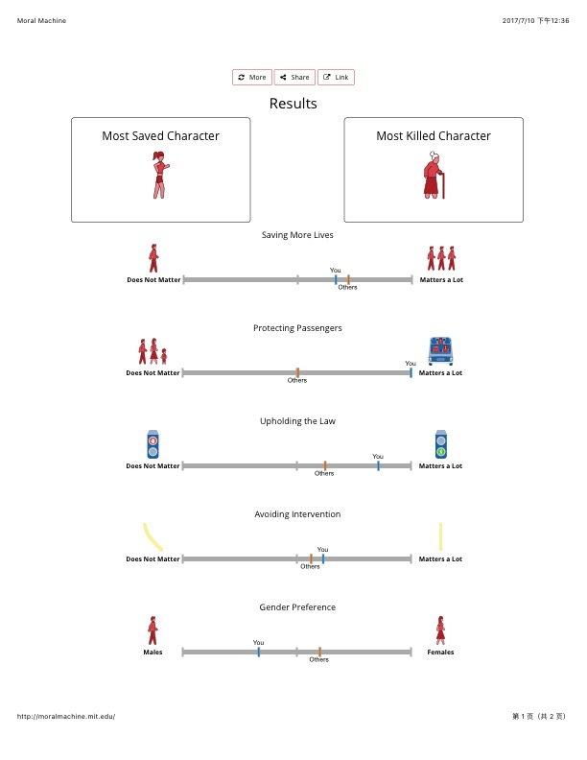

**Question 2**

1. In many emergency situations, obey the Act may not result in the best outcome. In the article, Lin comes out an example of small tree branch pokes out onto a highway while there is no incoming traffic, if we strict to the Act, the driver cannot drift to the opposite lane so the car comes to a full stop, but morally the driver would drift a little and pass around it. In this case, as there is no incoming traffic, drift a little to the opposite lane may not cause a big problem, and has low cost economically, but if the driver strictly follows the Act, a traffic congestion may happen until the branch is moved away from road, which causes a larger economic cost. So, following Vehicle Act and the Rules of Road may not be the best choice in some unexpected situation when we take total social cost into consideration.

Another example, if there is a heavy fog suddenly rise on a highway which have a great impact on driver’s sight, most of time drivers speed down even under minimum limit to make sure have enough time to react to emergency which is reasonable in ethics but not in laws. However, if strict to road rule, even the minimum speed may cause an accident in case of lacking reaction time, which is not quite sound in ethics but free from laws.

So, strictly follow the Motor Vehicle Act and associated with Rules of Road may not be appropriate all the time. People should do their own judgement in different scenarios. Ethics and laws may have conflict sometimes, letting autonomous vehicle strictly follow the laws may lead to a worse situation in big-picture.

1. The difference between autonomous car programmers and human drivers is the process of making decision, the programmers should teach the autonomous car to make a judgement about surroundings during the car is started, while human beings don’t need to have a special lesson for that. Also in many emergency situations, human drivers may have no time to make a good decision because of the suddenness, but there is no such difference between any situations for an autonomous car because it is all programmed, and programmers have enough time to test every kind of scenarios, so the programmers bear more responsibility for bad out comes. This is the difference between levels of responsibility of programmers of autonomous vehicles and drivers of conventional vehicle.

I agree with the author’s conclusion because the programmers of autonomous vehicles are creating decision making process for a vehicle, which has no ability of self-judgement. In another way, every judgement can be regarded as a judgement made by programmers when they do the coding. So, programmers are taking responsibility for all the judgements that an autonomous vehicle made. Meanwhile, the time of making decision should be calculated from the situation analysis to the decision comes out. Under this method, autonomous vehicles have much longer time to decide, because the programmers start situation analysis when they enter the first line of the program, while human driver start their situation analysis instantly. In conclusion of my own analysis, programmers have responsibility for judgements that autonomous vehicles make, and they have more time to make that judgement compare to human drivers, so that autonomous vehicle programmers should take more responsibility than human drivers.

**Question 3**

In this case, Kate is under a dilemma that whether report the information, which is the weight of AV passenger’s life equals to the weight of pedestrian’s life, while the advertising claims “heavily weighted in favour of the survival of the passengers of our vehicles”.

Before Kate make her final decision, I would suggest her to re-think about the advertising claim, “in favour of the survival of the passengers”, it is applied to general situations, because unexpected situations are unpredictable and unmeasurable, they should not be taken into consideration. How to prevent any death is the problem before programmers think about who is going to die, an autonomous vehicle should be programmed well to avoid all kinds of foreseeable dangerous and save passengers and pedestrians at the same time in every general situation. If programmers have done this part of code perfectly, the advertise claim is achieved because programmers do consider much for AV passengers. But there always some extreme emergency situations happen on road that not foreseeable, even human being drivers cannot make a proper decision, so under this kind of situation, request autonomous vehicle comes out with a prefect decision is not realistic, so how to evaluate the judgement made by autonomous vehicles should be taken into consideration.

What I recommend Kate to do based on utilitarian ethics perspective is re-think about the process of autonomous vehicle system value the outcome, make some changes to fit the advertise claim. The utility of making that information public may result in a negative utility because of the warning from legal department have a negative impact on her career, but if she does not report that information, and try to improve the system, she can be promoted because of her great contribution to the company, which holds a positive utility. A positive utility is always greater than a negative one, so work on the program itself is the thing I recommend Kate to do.

Basing on utilitarian ethical perspective, programmers should add a utility evaluating system into the judgement system of autonomous vehicles. The main job for the utility evaluating system to do is to evaluate the utility of an unavoidable accident, every piece of information should have a weighted effect on the utility calculating, including but not limited to death toll, social loss, passengers and pedestrians’ occupation, age, gender, and physical fitness. After specifying weights of every part of total utility, the system can calculate a more proper judgement base on utility in a big picture. Which has a higher possibility to result in a lower social cost of an accident.

How can we determine proper weights to add on the subjects related to utility calculation? As different subjects have different evaluating criteria, even some subject variables are qualitative rather than quantitative, how to build up a general model to estimate all kinds of subjects is a difficult problem for programmers to solve. What more complex is that different people may have different preference upon the same situation. So, what I have in mind is turn every qualitative variable into quantitative variable, money. For instance, the occupation can be calculated by annual salary, and age can be calculated by the income that person can earn in his or her rest of life, etc. Programmers can do some research on those quantitative variables and result in a roughly report. Base on the report, they can build up a mathematic model to estimate how do people weight different subjects on the road generally.

After programmers have a rough model in hand, when people buying an autonomous vehicle, they should be asked to do a test about their personally preference. The result comes out from this test is used to edit weights of subjects slightly so that they can match up with the buyer’s method of evaluating. Also by design buyers’ special model, their autonomous vehicles are supposed to make judgement which is like theirs under an emergency.

Besides the foundation of an evaluating model, foundation of a criteria to comment on whether the program makes a reasonable judgement is also a big problem that worth discussing. In a Catch-22 situation, there is hard to say which way is right or wrong, people mostly pick one they prefer to go base on their preference. And preference is kind of a result of people’s evaluation of the situation. So, there should be a track of the evaluation process of the program, when accident happened, print out this decision-making process and compare with some human beings’ decision-making process, if people cannot tell which piece is made by human beings and which one is made by the program, the programmers should not be judged, because they coded a reasonable outcome.

I mostly analysis based on utilitarian ethical perspective, because this perspective is much easier to track. Assume a driver intentionally hit a pedestrian， when police come to investigate, he says he was tend to save the pedestrian’s life but just did not make it right. It is hard to identify whether he is lying or not. Kantian ethics perspective values motivation more than consequence, but motivation is a qualitative variable that hard to measure, while utilitarian is based on utility which is a quantitative variable that can be easily measured. This is the reason why I believe utilitarian ethics perspective is more proper way to be used in an autonomous vehicle dilemma case.

If I were a Kantian perspective analyser, I would suggest Kate make this information public, because the motivation of her to do this is showing the real information to public and do not want people being fooled, which is a good motive. But if she does so, although public get what they are supposed to know, herself may get into big trouble because other company may assume she is motivated by an evil purpose and think she is a commercial cheater, which is totally bad for her career.

So, comparing two different kinds of perspective, utilitarian is more suitable to Kate’s situation, not only good to herself, but also good to the autonomous vehicle programming development.